TAYLOR SERIES:
INTRODUCTION:
To find the numerical solution of the equation
 = f(x,y) ----------------(1)
Given the initial condition y(x₀) = y₀. ----------------(2)
Now, we expand y(x) about the point x = x₀ in a Taylor’s series in powers of (x-x₀). That is,
y(x) = y(x₀) + 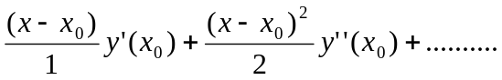 ----------------(3)
where y^{(r)}(x₀) = 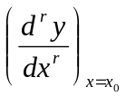
(i.e)., y(x) = y₀+ 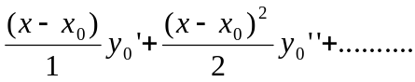
y(x) = y₁ = y₀+ 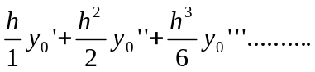 -----------------(4)
where h = x₁-x₀ or x₁ = x₀+h.
To find 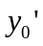, 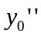…… we use (1) and its derivatives at x = x₀. Though the series (4) is an infinite series, we can truncate it at any convenient term, if h is small and the accuracy is obtained. Now, having got y₁, we can calculate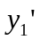, 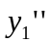……by using y’ = f(x,y).
Now expanding y(x), in a Taylor’s series about the point x = x₁, we get
y₂ = y₁+ 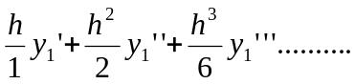 -------------------(5)
Proceeding in the same way, we get
y_{n+1} = y_{n}+ 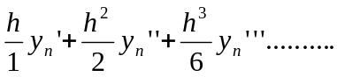 -------------------(6)
(6) is an infinite series and hence we have to truncate at some term to have the numerical value calculated.
PROBLEMS:
- Solve y’ = x+y , given y(1) = 0, and get y(1.1), y(1.2) by Taylor series method.
Sol:
Here x₀ = 1,y₀ = 0, h = 0.1, x₁ = 1.1, x₂ = 1.2
y’ = x+y y₀’= x₀+y₀ = 1+0 = 1
y’’ = 1+y’ y₀’’ = 1+y₀’=2
y’’’= y’’ y₀’’’ = 2
y^{iv} = y’’’ y₀^{iv}=2 etc
By Taylor series we have
y₁ = y₀+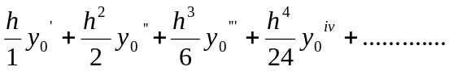
y₁ =y(0.2) = 0+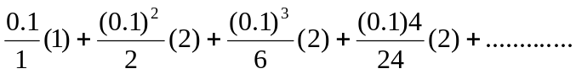
= 0.1+0.01+0.00033+0.00000833+………..
y(0.2) = 0.11034.
Now ,take x₁ = 1.1, y₁=0.11034
y₁’= x₁+y₁ = 1.1+0.11034=1.21034
y₁’’ = 1+y₁’=2.21034
y₁’’’ = y₁^{iv} = 2.21034 etc
y ₂ = 0.11034+
= 0.11034+0.121034+2.21034(0.005+0.00166+...
y(1.2) = 0.24280.

- Using Taylor series method, find y at x = 0.1,0.2 given y’ = x²-y, y(0) = 1.
Sol:
Here x₀ = 0,y₀ = 1, h = 0.1, x₁ = 0.1, x₂ = 0.2

y’= x²-y y₀’= x₀²-y₀ = -1
y’’ = 2x-y’ y₀’’ = 2x₀-y₀’=1
y’’’= 2-y’’ y₀’’’ = 2-1=1
y^{iv} = -y’’’ y₀^{iv}=-1 etc
By Taylor series we have
y₁ = y₀+
y₁ =y(0.1) = 1+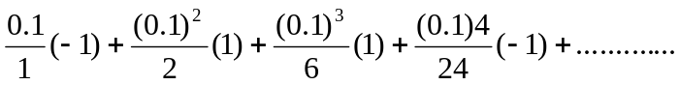
= 1-0.1+.005+.000166-.0000416
y(0.1) = 0.905125.
Now ,take x₁ = 0.1, y₁=0.905125
y₁’= x₁²-y₁= 0.01-0.905125 = -0.895125
y₁’’ = 2x₁-y₁’=0.2+0.895125 = 1.095125
y₁’’’ = 2-y₁’’’ = 2-1.095125 = 0.904875
y ₂ = 0.905125+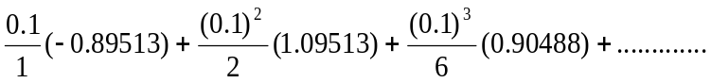
y(0.2) = 0.12827.

